**Data Science Portfolio**

Wenhang Bao

204 W 108th ST | New York, NY 10025 | (917)714-6682 | wb2304@columbia.edu

Github: <https://github.com/HolyMonarch> Linkedin: <https://www.linkedin.com/in/wenhangbao>

This is my data science portfolio where I present some results from my previous projects. I completed these project independently in a different way. If I previously used R, I would use Python in this portfolio, except for those functions that could not be substituted like CNN in Python.

1. Image Classifier
   1. Abstract

We have a set of 2000 images of poodle and fried chicken. The objective of this project is to create an AI program that accurately distinguish pictures of poodle dogs from pictures of fried chicken. The portability of this AI program (holding storage and running memory cost) and the computational efficiency (test running time cost) are of great concern. So the trade-off between training time and accuracy is of great significance.

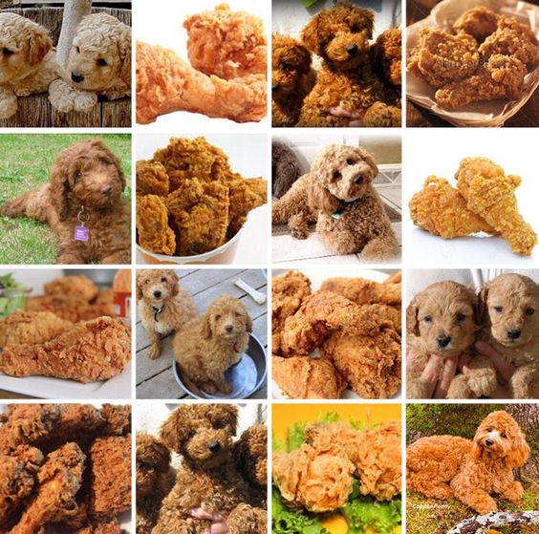

Github: <https://github.com/TZstatsADS/Fall2016-proj3-grp3>

* 1. Methods
     1. feature engineering

We first did feature engineering. Here we used SIFT algorithm to extract features from these images. After we got over 700,000 descriptors, we selected k-means clustering as the dimensionality reduction strategy. We clustered these features into 5000 groups and use bag-of-words methods to obtain the final SIFT features.

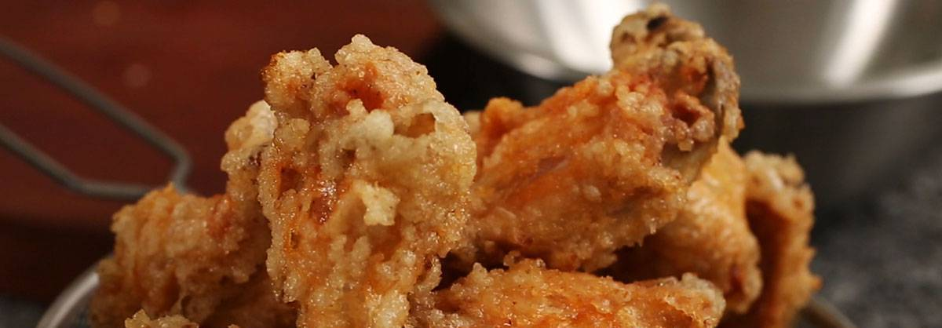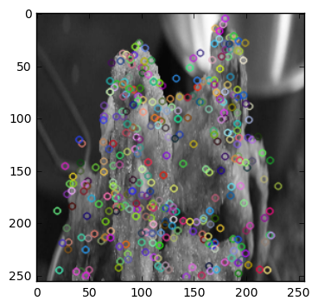

* + 1. Model

I used SIFT features and different Machine Learning models to build the AI program. In the project we built SVM, random forest, GBM, etc. with R. We used GBM with SIFT features as our baseline model.

Here I built only Random Forest with Python.

After tuning model parameters, we compared the performance of ML models (SVM, Random forest, GBM, CNN) and select CNN as our final model.

|  |  |  |  |  |
| --- | --- | --- | --- | --- |
| Classifier | GBM | SVM | RanForest | CNN |
| Training Time(s) | 7000 | 1100 | 1400 | 240 |
| Accuracy(%) | 67 | 64 | 64 | 94 |

* 1. Results

We successfully built model which could improve the accuracy to 94%, which also could be better with more delicate parameters. Feature engineering and parameters tuning take 70% of the time. The trade-off between time and accuracy is of great significance because we have enough time for this project, but we will not have so much time allows us to tune parameters repeatedly.

1. Trees in New York
   1. Abstract

The objective of this project is to create an application which could help tree lovers to understand and locate all kinds of trees planted besides the street all over New York City. The data were downloaded from NYC open data with over 460,000 records. This application also provides statistical analysis of problems these trees are facing.

* 1. Methods
     1. Tableau for EDA

I used Tableau for basic data analysis. It’s of efficiency and accuracy. With the data being mapped in the graph, we could better understand our application then design the UI site. Figure 1 is about the distribution of trees in New York. Figure 2 is about the health condition.

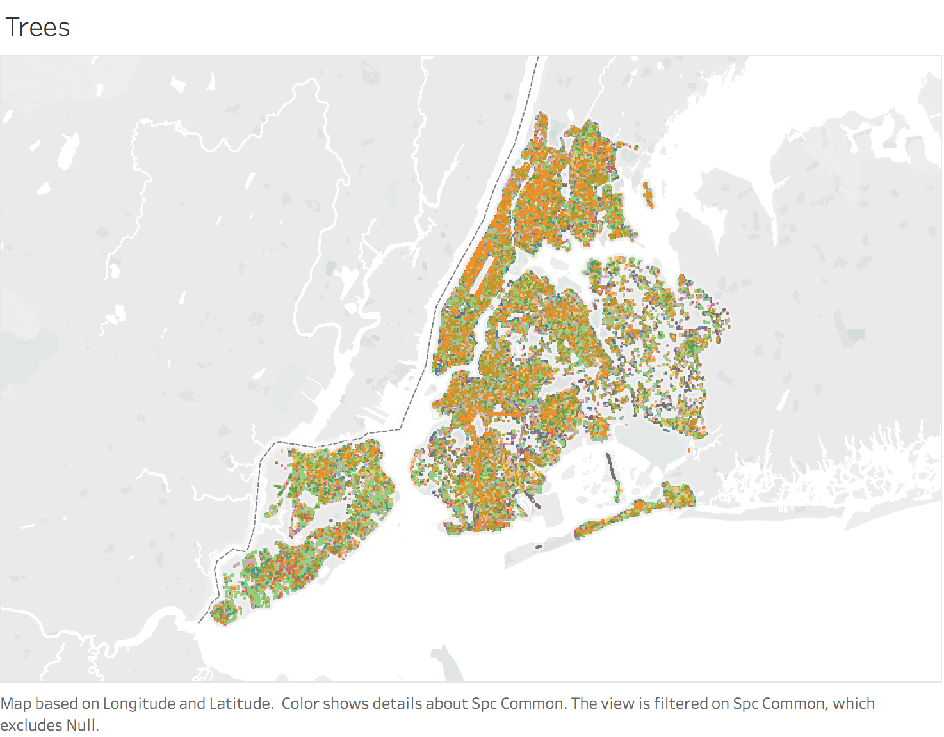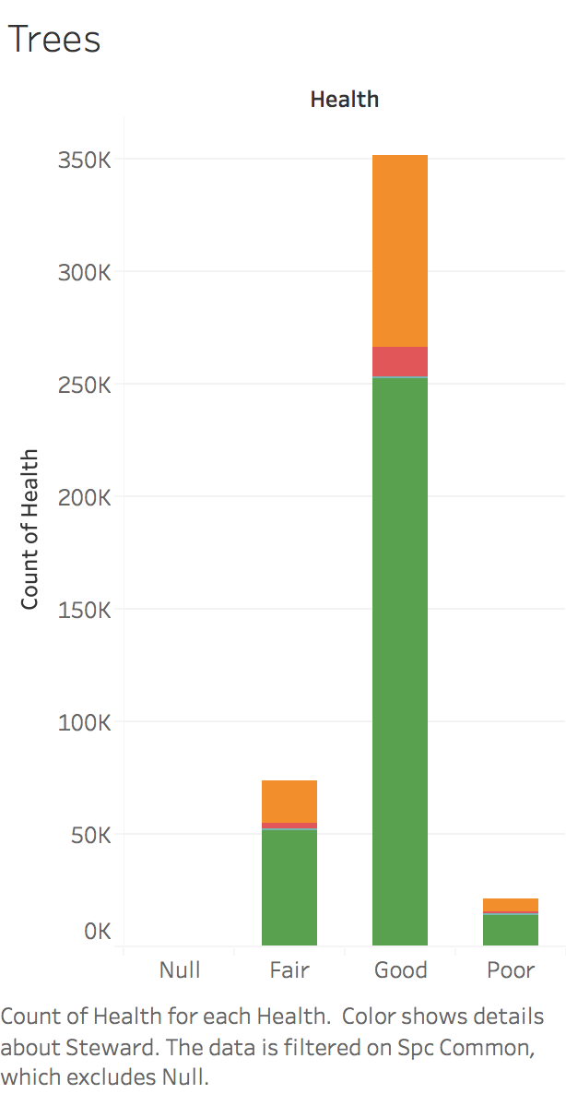

* + 1. RShiny

I used RShiny to develop the application. The application has 4 functions:

1. The distribution of trees in New York
2. Analysis of the negative effect
3. Clustering of geographical area
4. Text mining

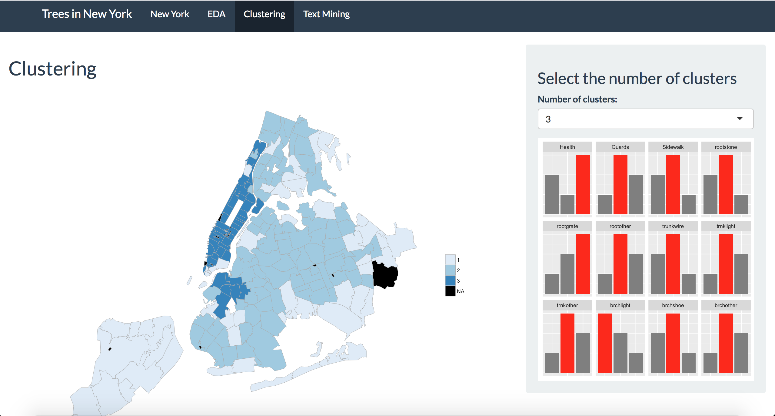

* 1. Results

Our application and statistical analysis can help tree lovers find one specific kind of tree. Also, it tells us the health condition of trees in different area. The clustering results told us that Manhattan and upper Brooklyn performs better than the rest area because these places provide better protection to the trees. That could help the government in city decoration and regularization.

1. Hillary Clinton’s email analysis
   1. Abstract

Here I used the famous Kaggle dataset, Hillary Clinton’s email. Throughout 2015, Hillary Clinton has been embroiled in [controversy](https://en.wikipedia.org/wiki/Hillary_Clinton_email_controversy) over the use of personal email accounts on non-government servers during her time as the United States Secretary of State. The objective of this project is to understand the focus of her email and to categorize them.

* 1. Methods
     1. Word Cloud

Here I extracted emails only related to president. Then I used Python package WordCloud to visualize the content of these emails, and try to depict keyword.

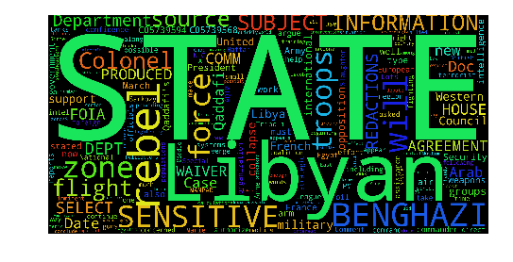

* + 1. LDA model

I tried to fit LDA model to categorize these emails. We could notice that Topic 1 may be related with her meeting arrangement, Topic 2 may be related with international affairs, etc.

But also there are topics that make no sense like Topic 5.

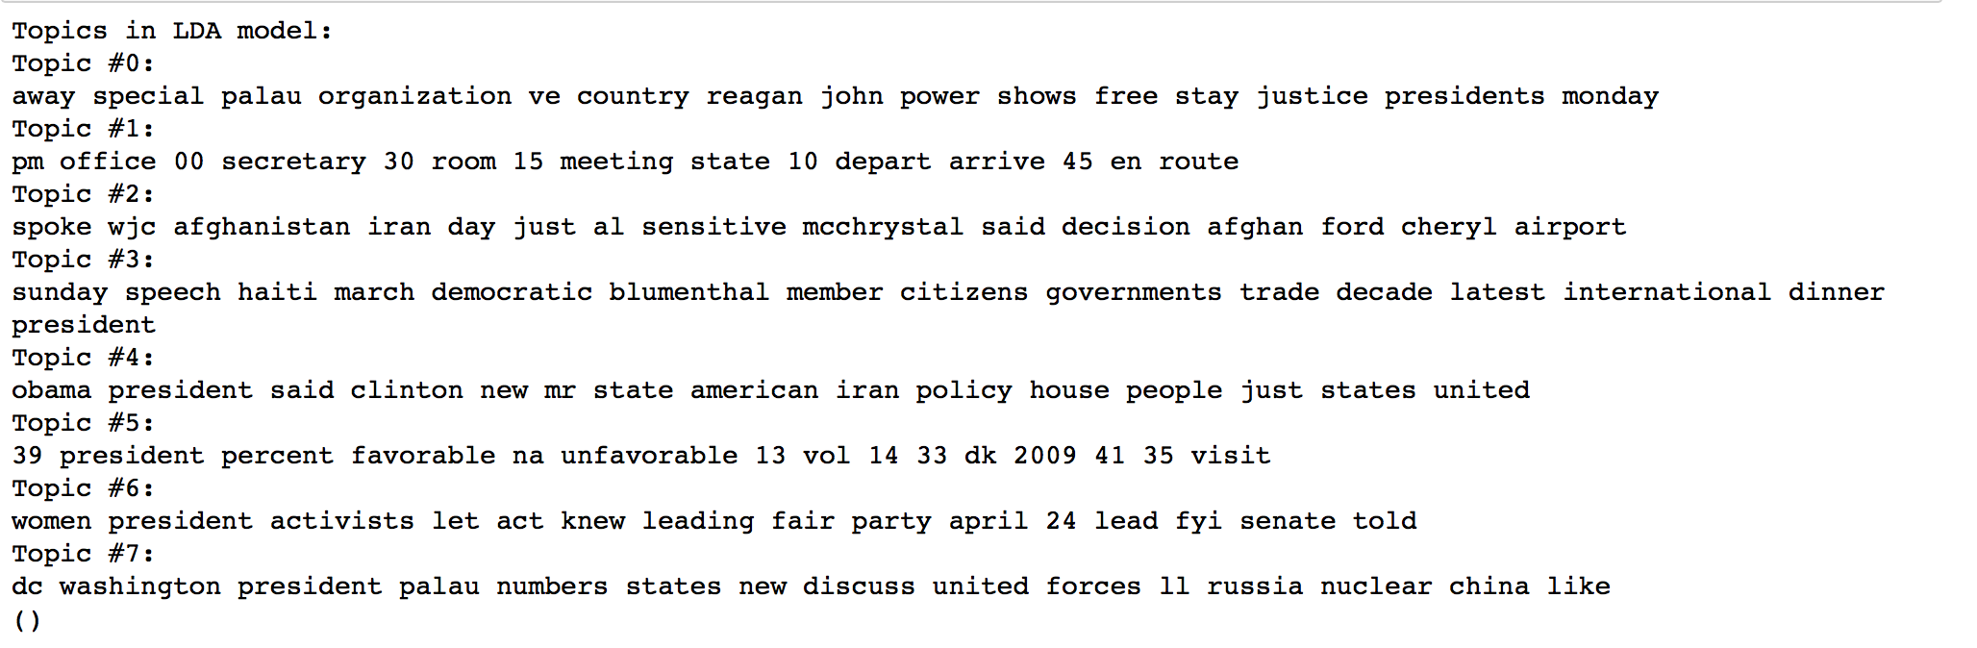

* 1. Results

Here I used some simple ways to analyze these text and get some insights about what the Secretary of State were doing. I could try like n-grams model in the future for further analysis.